Bombin’ Man

User Manual

By Miguel Duarte and António Cruz

# LIST OF ALL SCREENS

The screens that exist in *Bombin’ Man* are the following:

* Server Screens:
  + Lobby
  + Game Screen
  + Win Screen
* Client Screens:
  + Main Menu Screen
  + Connect Screen
  + Waiting for Server Screen
  + Controls Screen
  + Win Screen
  + Lose Screen
  + Server Full Screen
  + Lost Connection Screen

# SERVER SCREENS

### 

### 

### Lobby

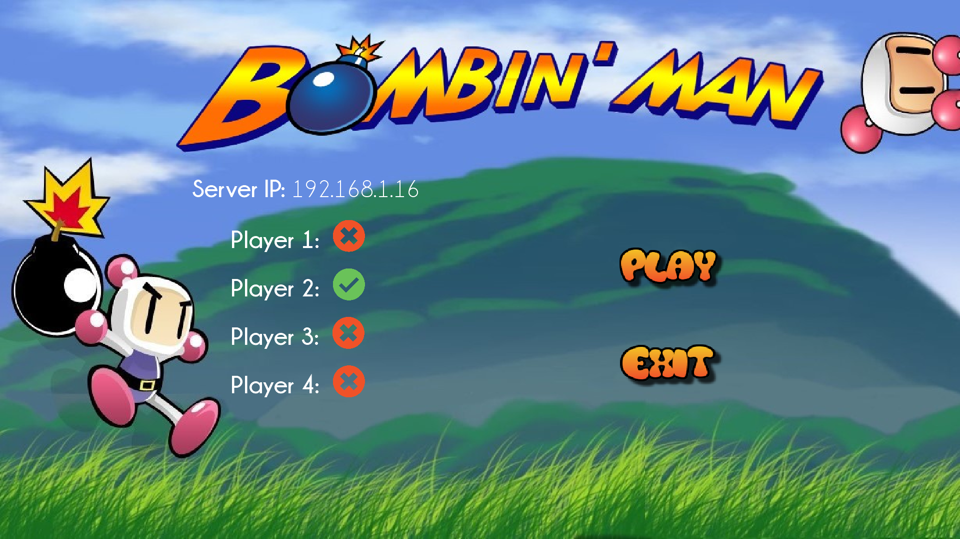

In the lobby it is possible to view the server IP through which the clients must connect and the player connection status. There are two buttons available: The play button starts the game if at least 2 players are connected and the exit button exits the application.

### 

### 

### 

### Game Screen

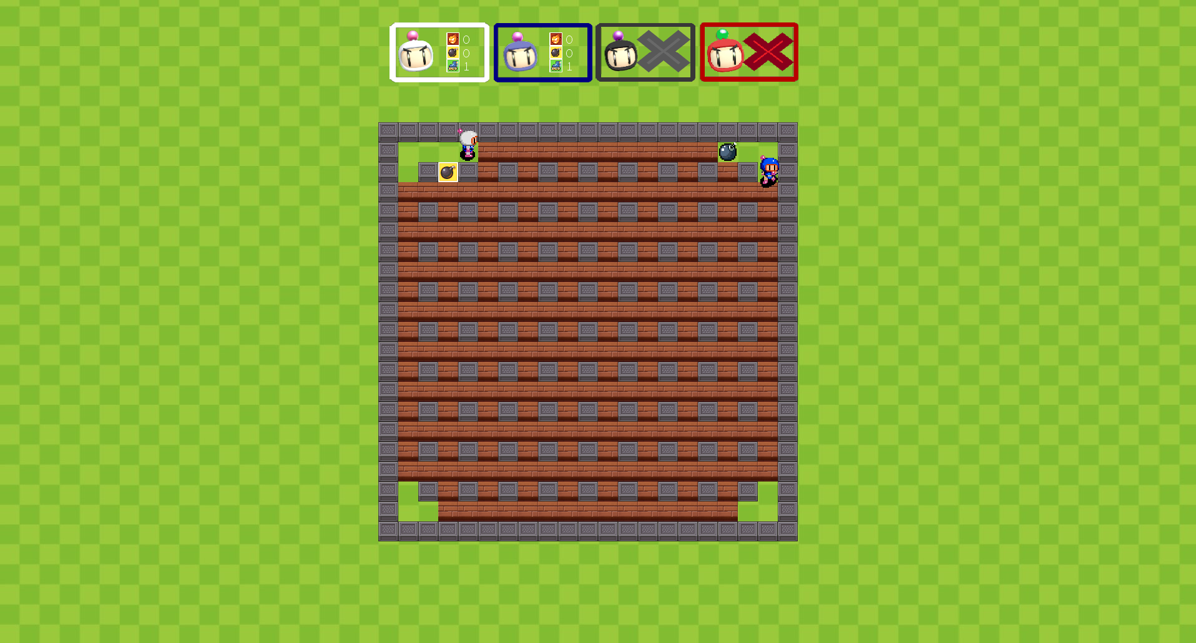

The Game Screen is shown while playing. The game map, where the players move and interact with the world is shown in the middle, and the player HUD is shown above it. This HUD (Heads-Up Display) shows relevant information about each player, such as their number of powerups and their connection status and if they have already lost the game or not.

In this state, the players can use bombs to break the brown bricks and spawn powerups, and try to eliminate each other with these explosive devices! The players are controlled via the mobile app.

### Win Screen

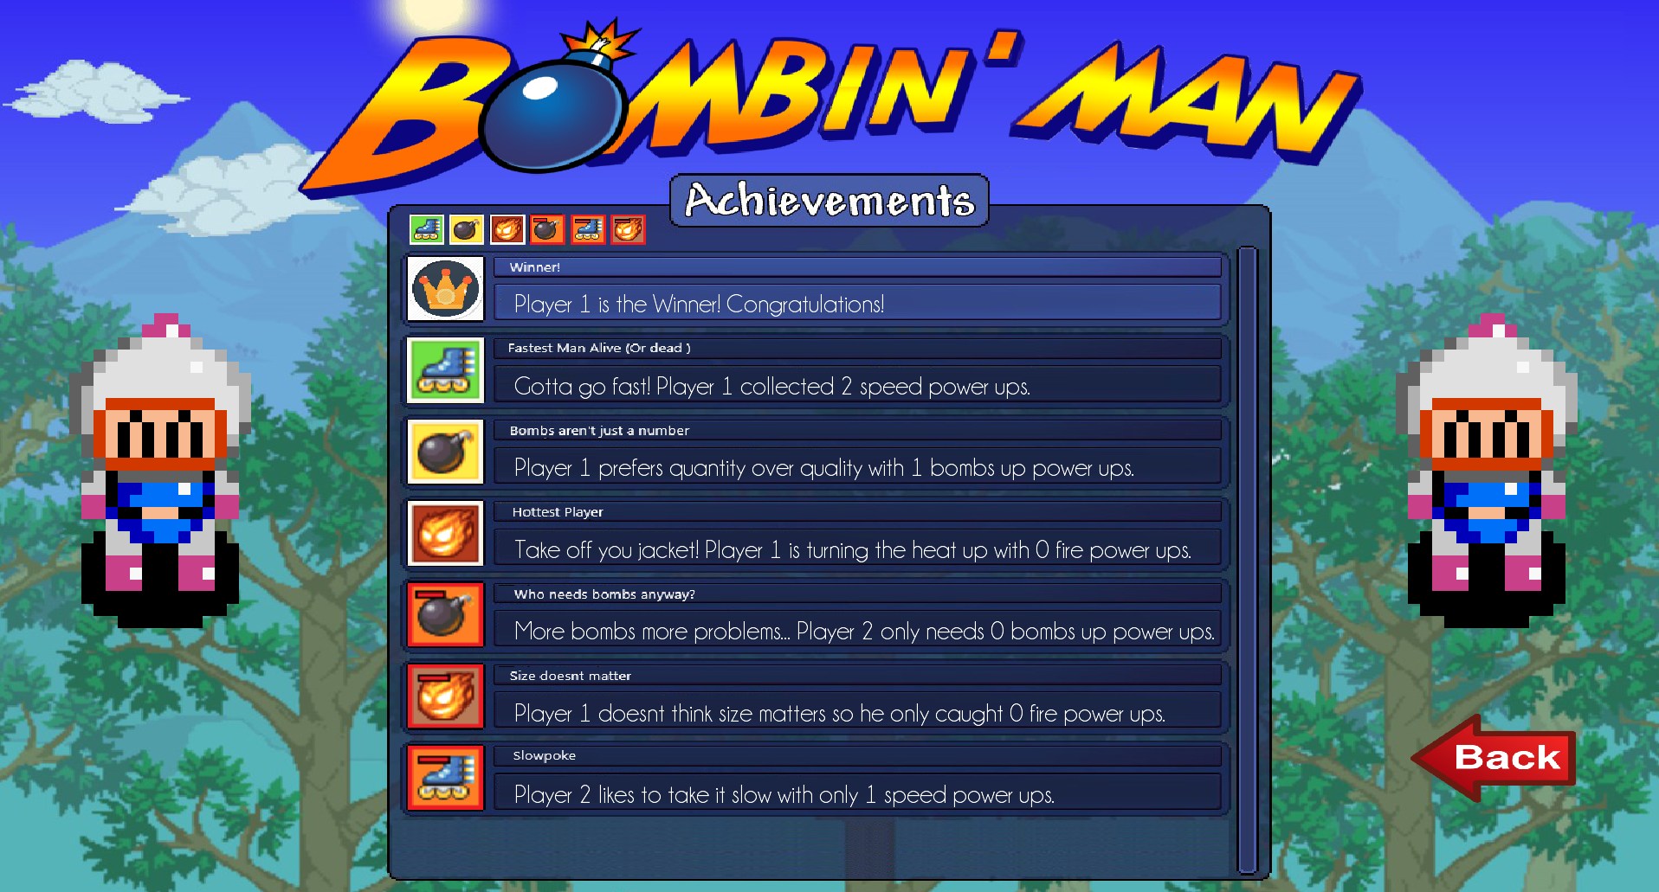

The Win Screen is shown when a match is completed (when only one player is left standing). It shows a winning animation of the winning player on each side and some achievements in the center of the screen. The back button can be pressed to return to the lobby.

# CLIENT SCREENS

### Main Menu Screen

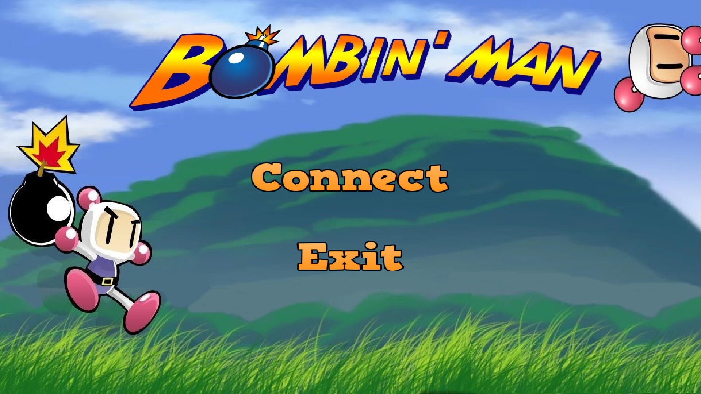

Initial screen of the mobile application. The connect button enters the Connect Screen and the exit button exits the app.

### Connect Screen

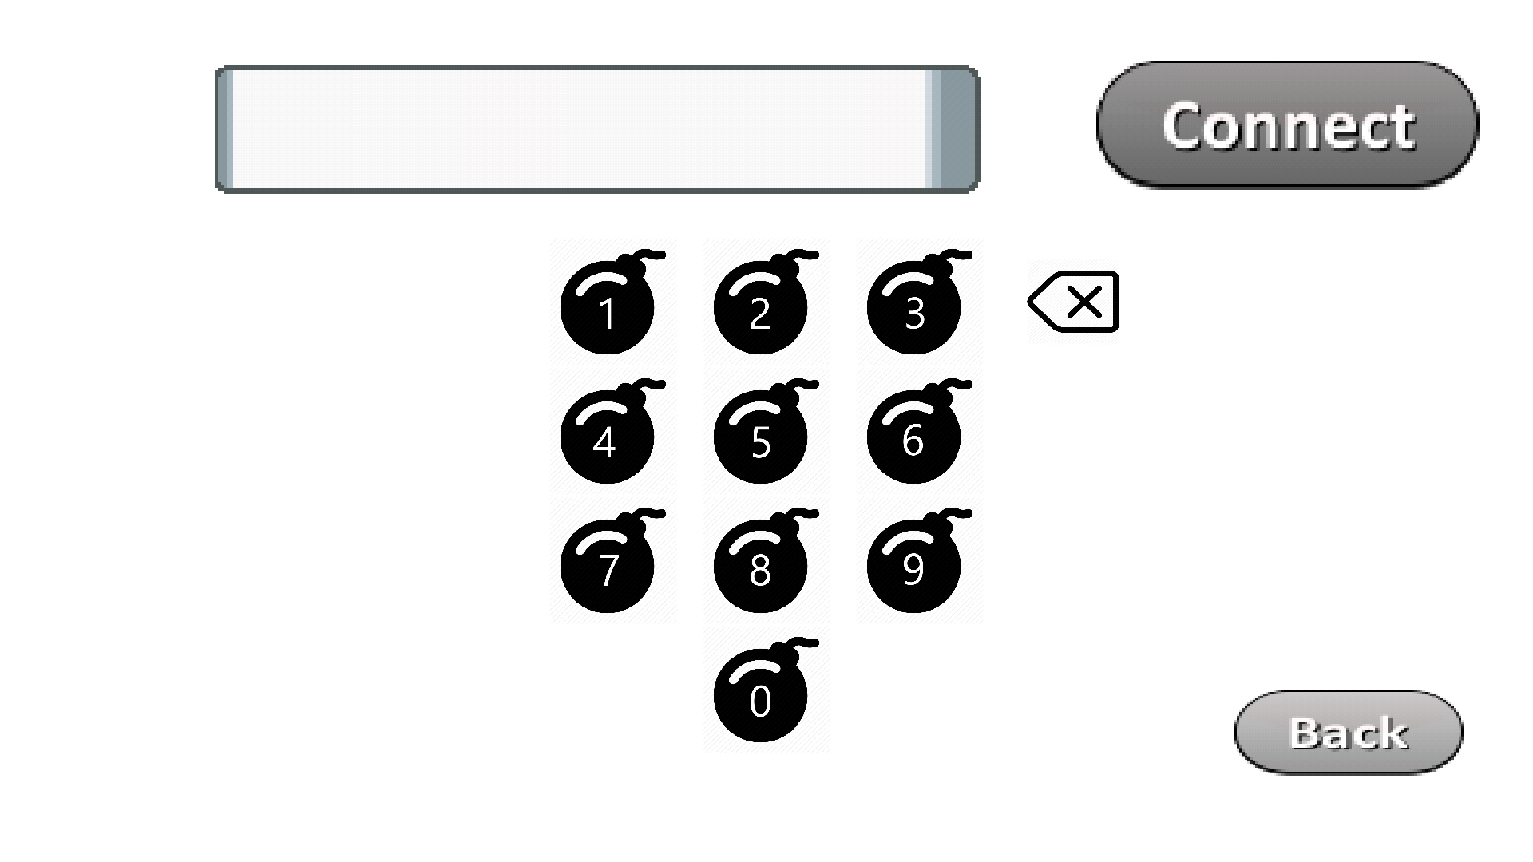

The screen that is used to connect to the Game Server. Here a zero-padded IP (192.168.1.6 becomes 192168001016) must be entered in order to connect to the server. By pressing the connect button a connection is attempted. If successful, the screen is changed to the Waiting for Server Screen. The back button can be pressed to return to the Main Menu.

### Waiting for Server Screen

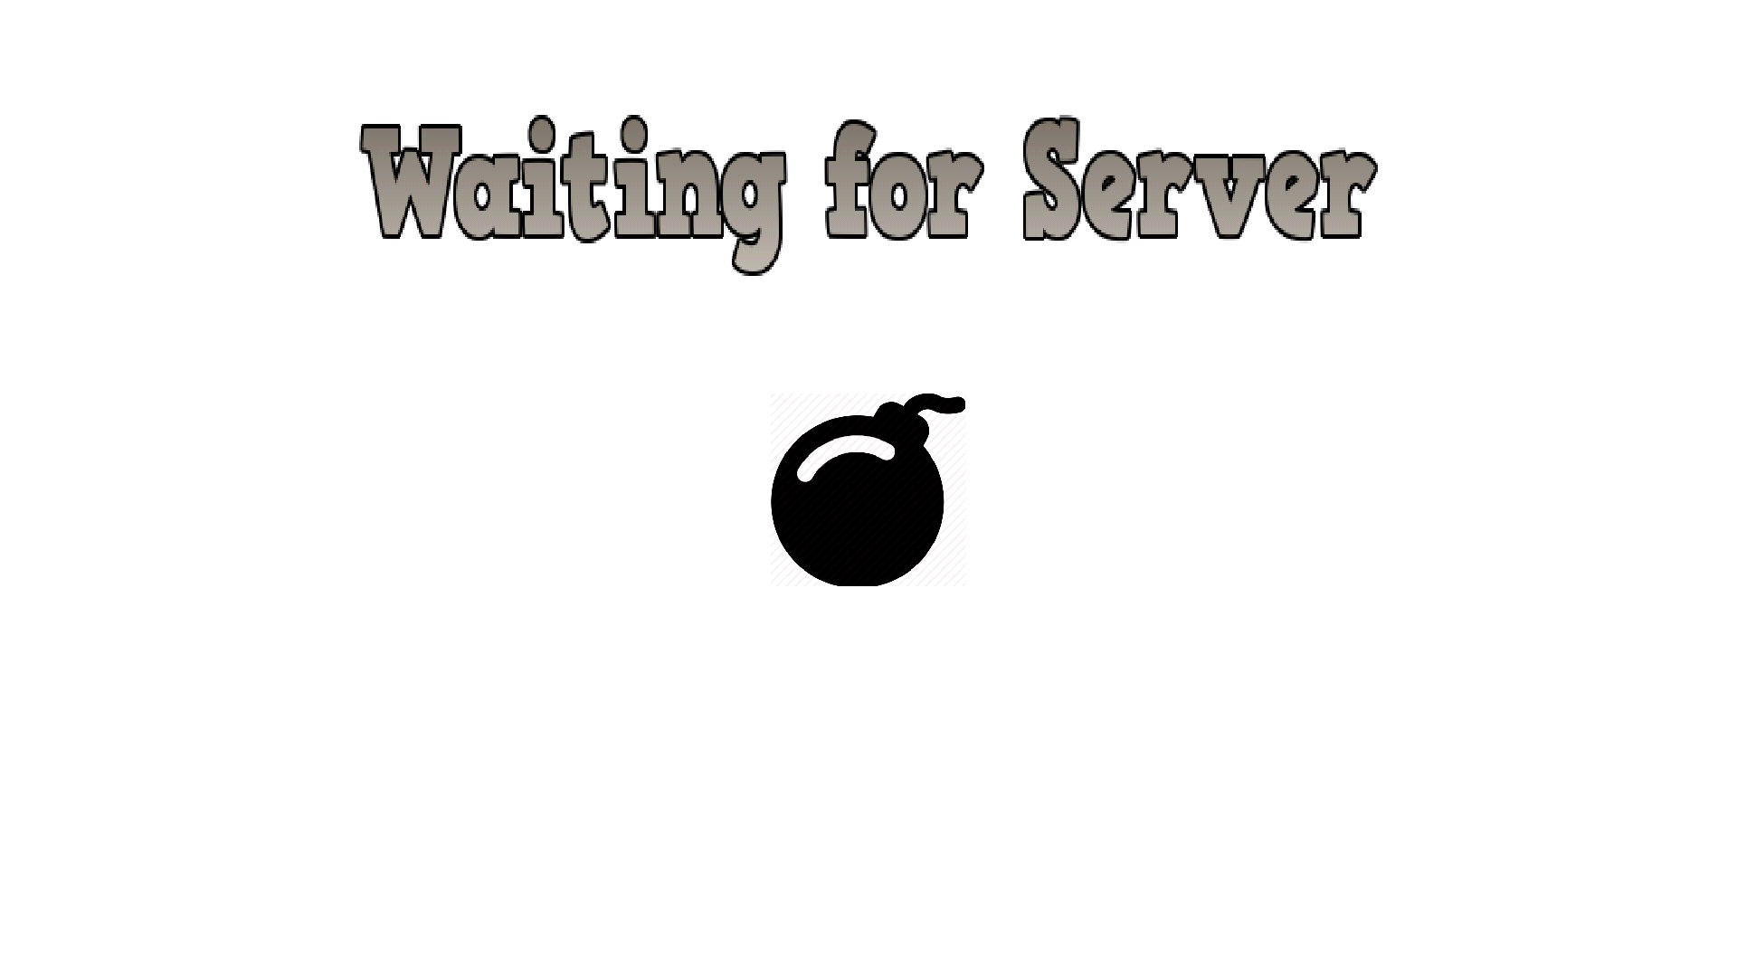

This is the screen presented after connecting to the server, in which the client is waiting for the server to start the game.

### Controls Screen



After the game is started, this screen is entered. The left joystick can be used to move the player character and the left button to place a bomb. In case another player picks up the stun power up, the phones of other players will begin vibrating and they will lose the ability to control their character until they shake their phone to break out of this status condition.

### Win Screen



This screen is presented in the end of the game, to the player that won the game. Pressing back returns the player to the Main Menu.

### Lose Screen

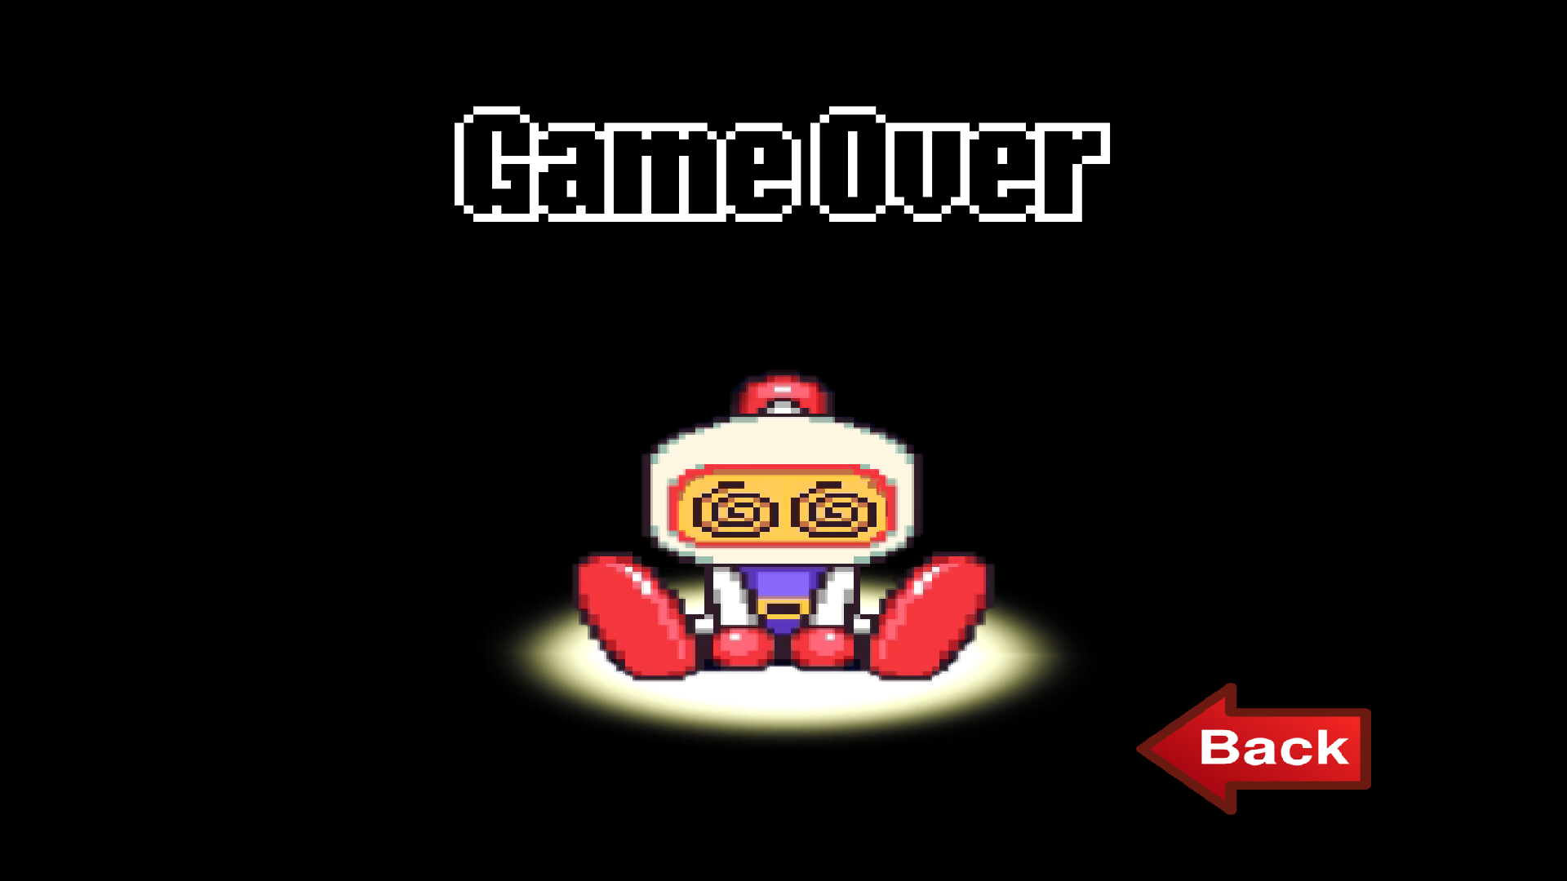

This screen is presented when a player loses the game, immediately after they lose. Pressing back goes back to the Main Menu.

### Server Full Screen

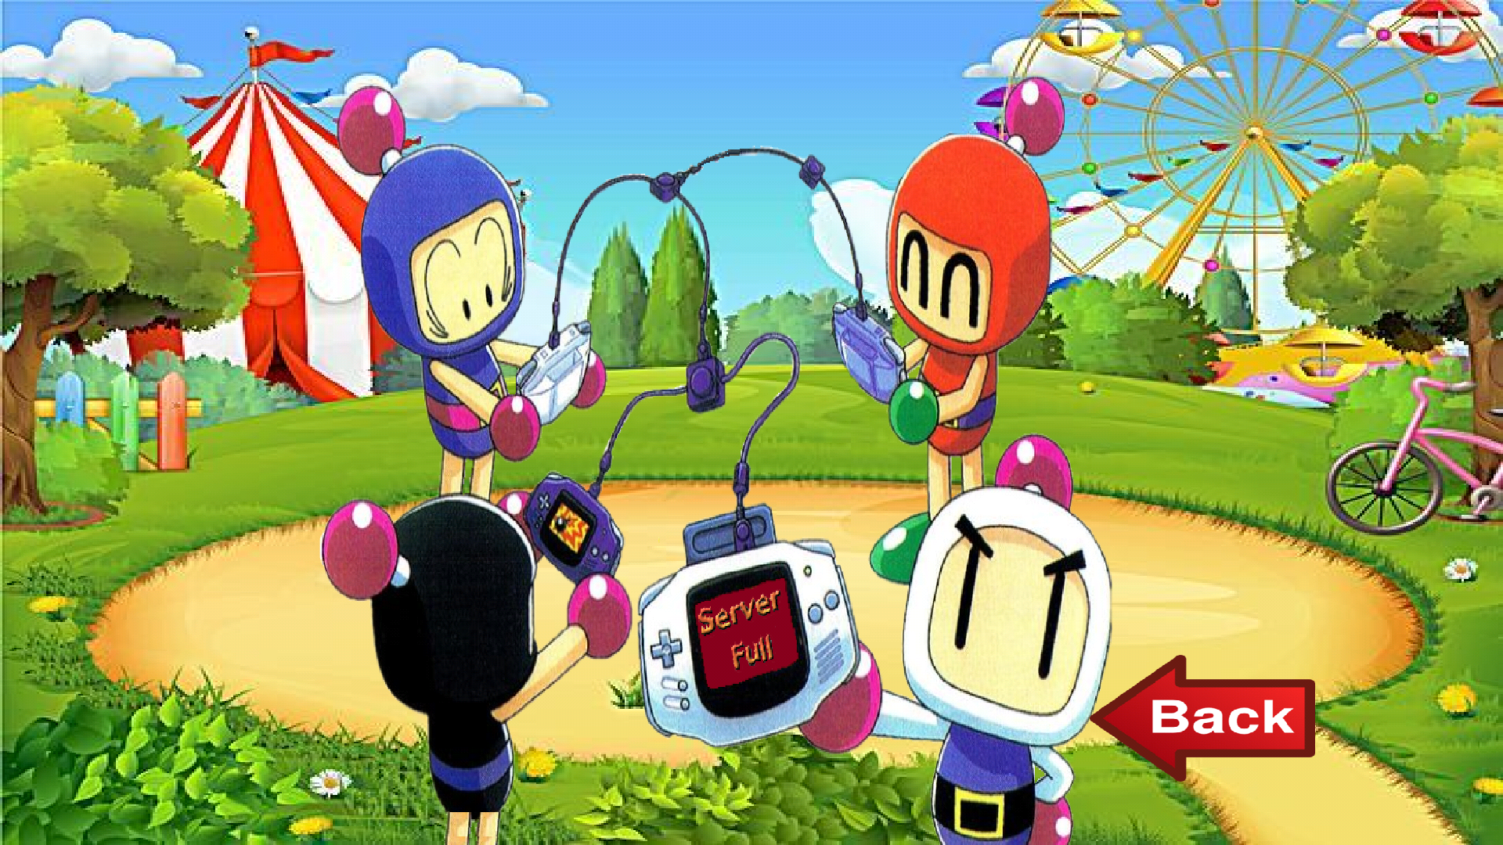

Screen shown when the server is full or is already playing, showing that the connection cannot (currently) be made. Pressing back travels back to the Main Menu Screen.

### Lost Connection Screen

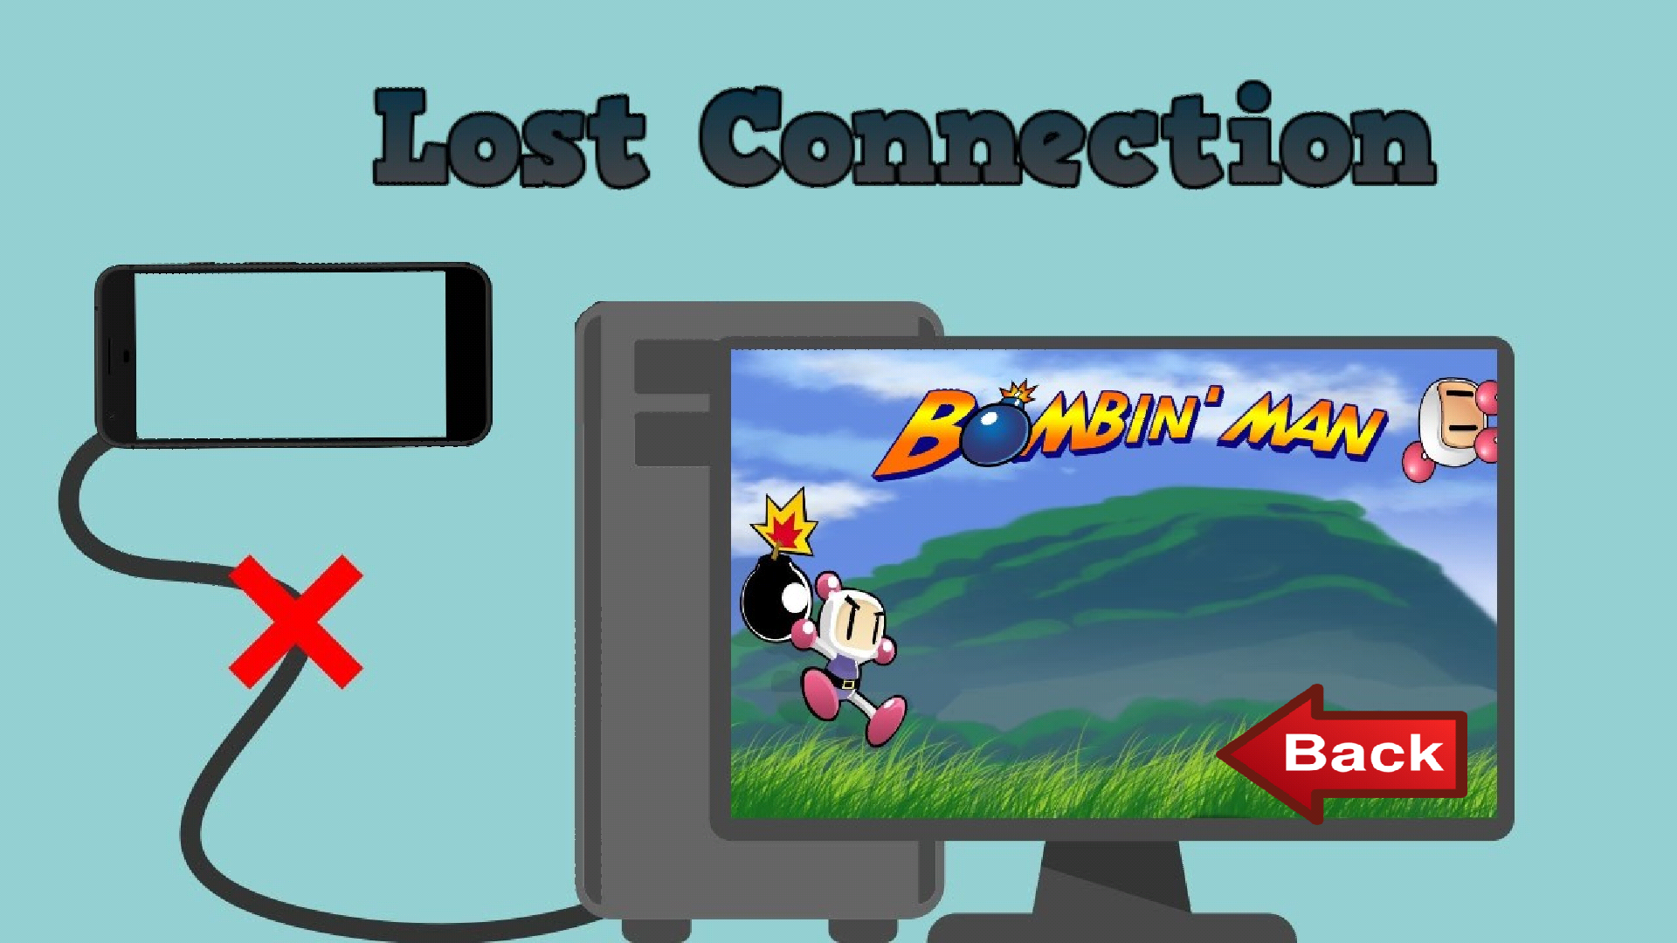

Screen shown when the player was connected to the game but lost connection to it. It normally is associated to losing access to the server network or due to the server closing mid-game (the server owner closed the program or the server lost internet access, for example).